|  |
| --- |
| **misrtronics** |
| **DIGITAL FREQUENCY MEASUREMENT SYSTEM DESIGN**  **FOR THE FT-101 RECEIVER** |
|  |
|  |
| **Dr. Aladdin Assisi** |
| **4/16/2021** |

***This document describes in detail the new unit that has been designed to measure the instantaneous value of the signal frequency being received by the FT-101 HF transceiver. The new unit consists of two main sub-units; the Frequency Measurement Unit (RFMU) and the Counter Unit (CU). The RFMU builds up a rectangular wave with the same frequency of the signal being received by the FT-101, while the CU counts and displays the number of pulses received every second. Many design challenges have been solved and thorough simulation techniques have been repeatedly applied to assure that the frequency to be measured exactly equal that being received by the FT-101.***

**DIGITAL FREQUENCY MEASUREMENT SYSTEM DESIGN**

**FOR THE FT-101 RECEIVER**

1. **INTRODUCTION**
2. The design task is to design a unit that can measure both the transmitted signal frequency and the received signal frequency of the FTY-101 HF Transceiver.
3. Measuring the transmitted signal frequency is straightforward. A sample of the transmitted signal is taken from the leftmost point of the rear panel. It is the RF signal output of the driver stage. This signal can be directly driven to the CU input.



**Figure 1. Rear of the FT-101**



**Figure 2. The PB1181 RF Unit**

1. To measure the received signal frequency is a big challenge for the following reasons:
   1. There are many RF signals at the receiver input. It is not possible to know which one is currently selected by the user without reading the current values of the course and the fine local oscillators
   2. The instantaneous signal being received is a very weak signal at the RF unit receiving input.
   3. The received signal is amplified in the successive heterodyning stages through a double down frequency conversion process where the original RF frequency value is lost.
   4. The only way to measure the received signal frequency is to reconstruct the RF signal from its three components:
      1. The 3.18 MHz detected signal at the receiver output
      2. The VFO instantaneous output signal.
      3. The RF oscillator instantaneous output signal
   5. It should be considered that:
      1. The 3.18 MHz signal frequency can be incremented or decremented by the side band shift according to the user’s selection (USB/LSB)
      2. The VFO frequency is continuously variable between 8.7 MHz and 9.2 MHz according to the fine tuning under the user’s control
      3. The RF oscillator frequency is user-selectable among ten different positions of the RF band switch in the FT-101 front panel.

Table 1 shows the ten frequency bands of the FT-101and the corresponding frequencies at different stages.



1. The received signal frequency measurement procedure consists of the following stages:
   1. Get the instantaneous 3.18 MHz received signal from the receiver output. (pin 4 of the Noise Blanker Unit). See Figure 3.
   2. Mix it with the VFO 8.7-9.2 MHz output fine tuning LO signal (Look at Figure 4).
   3. Pass the mixer output from a 5.52-6.02 MHz BPF to suppress the Upper Side Band (USB) output.
   4. Mix the resulting signal with the output of the RF Local Oscillator from the RF Unit (Figure 5).
   5. Filter out the Upper Side Band (USB) output. This was the greatest challenge; since the RF signal frequency changes between 1.5 MHz and 30 MHz, while the second local oscillator signal changes between 7.52 MHz and 35.52 MHz. It means that the USB signal to be suppressed changes between 13.04 MHz and 41.54 MHz. It means that the variation ranges of the desired signal and the spurious signal are interleaved, as it can be seen in Table 2 below.

**TABLE 2**

**FILTER SPECIFICATIONS**

**Second Solution**

|  |  |  |  |  |  |  |  |  |  |
| --- | --- | --- | --- | --- | --- | --- | --- | --- | --- |
| **BAND** | **Band Name** | **Crystal Freq.** | **Crystal**  **Detection Criteria** | **Correct RF**  **from to** | | **Undesired Image Spur**    **from to** | | **Required Image Suppression Filter** | **S21>-1 for** |
|  | **[m]** | **MHz** | **MHz** | **MHz** | **MHz** | **MHz** | **MHz** |  | **MHz** |
| **1** | **160** | 7.52 | f < 15 | 1.5 | 2.0 | 13.04 | 13.54 | BS13-20 | f <7.5 |
| **2** | **80** | 9.52 | f < 15 | 3.5 | 4.0 | 15.04 | 15.54 | BS13-20 | f <7.5 |
| **3** | **40** | 13.03 | f < 15 | 7.0 | 7.5 | 18.54 | 19.04 | BS13-20 | f <7.5 |
| **4** | **20** | 20.02 | f = 20.02 | 14 | 14.5 | 25.54 | 26.04 | BS20-30 | f <15 |
| **5** | **15** | 27.02 | 40>f > 25 | 21 | 21.5 | 32.54 | 33.04 | BS32-42 | f <21 |
| **6** | **11** | 33.02 | 40>f > 25 | 27 | 27.5 | 38.54 | 39.04 | BS32-42 | f <21 |
| **7** | **10A** | 34.02 | 40>f > 25 | 28 | 28.5 | 39.54 | 40.04 | BS32-42 | f <21 |
| **8** | **10B** | 34.52 | 40>f > 25 | 28.5 | 29 | 40.04 | 40.54 | BS32-42 | f <21 |
| **9** | **10C** | 35.02 | 40>f > 25 | 29 | 29.5 | 40.54 | 41.04 | BS32-42 | f <21 |
| **10** | **10D** | 35.52 | 40>f > 25 | 29.5 | 30 | 41.04 | 41.54 | BS32-42 | f <21 |

* 1. The first solution was to use an image rejection mixer to suppress the USB at every selected RF band. After many design trials, this solution was excluded since it was impossible to design an image rejection mixer with such an ultra wide band with a 20:1 BW (1.5 to 30 MHz output frequency band).
  2. The second approach to this problem was to divide the RF frequency band into three sub-bands, design three different band-pass filters each passing a certain desired frequency band and suppressing the corresponding spurious band as shown in Table 2; and switch the resulting signal among the three BPF’s according to the RF frequency band being selected by the user. The problem of detecting the band switch position was solved by detecting the instantaneous value of the LO frequency and use it to control the switch. The system was completely designed with this solution.
  3. In order to decrease the system complexity and size, a third solution has been adopted with a single specially designed LPF instead of the three switched filters of the second solution. The LPF has been optimized such that the desired signal is higher than the spur by more than 12 dB for each value of the different ten LO frequencies.
  4. It was assured through thorough simulation trials in time and frequency domains that an output comparator will ignore the spur if it is lower than the desired signal by more than 10 dB.
  5. The third solution has been fully designed and fully simulated in time and frequency domains for the ten frequency bands. The system gain and frequency response have been repeatedly optimized for perfect operation at the ten frequency bands.
  6. A zero detection precision comparator has been added at the output of the Frequency Measurement Unit (RFMU) to extract a rectangular pulse from every cycle of the sine wave at the final filter output.
  7. A fully hardware based counter has been designed with six digits of 7-segment display. The counter will display the measured frequency up to 30 MHz with 100 Hz resolution. Two decimal points will be always displayed at kHz and MHz beginning range.
  8. A 2D layout has been accurately designed for the system, from which an accurate 3D design has been generated. The 3D layout shows where the connectors between every two subsequent modules should be located.



**Figure 2. Noise Blanker Unit Output.**



**Figure 4. The PB-1056 VFO Unit Output Signal**



**Figure 5. The PB-1181 RF Unit LO2 Signal**



**Figure 6. FT-101 Simplified Block Diagram**



**Figure 7. FT-101 Detailed Block Diagram**

1. **How the FT-101 Selects the Received Frequency**

Figures 6 and 7 show the original simplified and detailed block diagrams of the FT-1014 drawn by Yaesu engineers. They describe in detail all exchanged signals among different modules of the transceiver.

From these two figures, the two stage heterodyne process can be understood as follows:

1. The received RF signal is mixed with the selected crystal oscillator output in the **PB1181** **RF** **Unit.**
2. In the **PB1180** **MIXER Unit**, the mixer output is filtered by a selective (5.52 - 6.02) MHz BPF. The BPF output is mixed with the VFO output which is fine tuned by the user to the required frequency.
3. The VFO output frequency, generated by the **1056 VFO Unit**, can be manually changed between 8.7 and 9.2 MHz.
4. In the PB1292 NB Unit, the second mixer output is filtered by a second BPF tuned to 3.18 ±0.25 MHz. The 3.18 MHz signal is further processed and demodulated in next IF and audio stages of the receiver.

I have redrawn these frequency management stages by GENESYS. A simplified block diagram of the FT-101 concentrating on the received frequency processing is shown in Figure 8.



**Figure 8. FT-101 Simplified Block Diagram drawn by GENESYS**

1. **The Rx Frequency Measurement Problem** 
   1. The transmitter frequency can be easily measured by taking a sample of the output signal before the power amplifier to the frequency counter.
   2. The situation differs in the receiver; since:
      1. The input signal is too low to be measured
      2. There are many input signals among which the receiver should select. The selection is done by tuning the receiver to a certain frequency and taking the signal possessing this selected frequency.
      3. There are two stages of down conversion. In the first stage, the receiver switches in one of ten different crystals as a first local oscillator to determine the frequency sub-band of the receiver. By mixing the input signal with the first local oscillator, the selected signal is down converted to the first IF (5.52 to 6.02 MHz).
      4. In the second stage, a Variable Frequency Oscillator is fine tuned to the exact required frequency between 8.7 MHz and 9.2 MHz as the second local oscillator. By mixing the first IF with the second local oscillator, the selected signal is down converted to the second IF = 3.18 MHz.
   3. Therefore, there is actually no RF signal in the receiver that can be detected and measured.
2. **The Adopted Method to Measure the Selected Receiver Frequency**
   1. The best solution is to create the RF signal to which the receiver desires to select and measure the frequency of this created signal.
   2. The RF signal is created in the same two steps:
      1. The 3.18 MHz signal is taken from the PB1292 NB Unit.
      2. The instantaneous fine LO signal is taken from the PB1056 VFO Unit
      3. The two signals are mixed and the mixer output is filtered by a 5.52 to 6.02 MHz BPF.
      4. The resulting signal is mixed with the currently selected crystal oscillator output.
      5. The mixer output is taken to the Frequency Counter Unit.
   3. The frequency measuring system is shown in Figure 9.



**Figure 9. The adopted method to measure the receiver currently selected frequency**

1. **The Amplitudes of The Three Input Signals as Measured by the Owner**

The project owner has measured the amplitudes of the three input signals to the new Frequency Measuring Unit as follows:

1. The First LO signal amplitude at the RF Oscillator output is 700 mV
2. The second LO signal amplitude at the VFO output is 150 mV
3. The received 3.18 MHz signal at the NB unit output is of the order of 20 mV

The RFMU design has been adapted to the above mentioned input signal levels.

If, at any time, the owner finds other signal levels different than those mentioned above, it is possible to adjust the system gains accordingly.

1. **The Designed Hardware to Measure the Received Frequency**

Two main units have been designed to measure the frequency to which the FT-101 receiver is currently tuned:

1. The Rx Frequency Measuring Unit (RFMU)
2. The Frequency Counter Unit (FCU).
3. **The Rx Frequency Measuring Unit (RFMU)**

This unit generates a radio frequency equal to that of the currently selected input sinal.

This is done at two stages:

* + 1. The 3.18 signal is mixed with the current VFO output signal (manually tuned by the user).
    2. The resulting signal is mixed with the RF output of the currently selected crystal oscillator (1 of 11 different crystals).

**6.1.3.** A buffer is used at each input port to guarantee unloading the oscillator from which the signal is taken in the FT-101. The buffer has very high input impedance, while its output is matched to the 50 Ohm impedance of the next mixer.

The functional diagram of the RFMU is shown in Figure 10.



**Figure 10. The RFMU**

1. **Verification of the output frequency bands**

In the following we try to verify for the output RF frequency bands of the FT-101 at different positions of the crystal selection switch.

The following table shows the different crystal frequency values and the corresponding expected values of the RF frequencies. We have got those values by subtracting the IF from each crystal frequency.

|  |  |  |  |  |  |  |  |
| --- | --- | --- | --- | --- | --- | --- | --- |
| **BAND** | **Crystal frequency** | **VFO**  **frequency** | **Fine IF** | **Total IF**  **fVFO - IF** | **Correct RF** | **Undesired spur output frequency** | **Required Filter** |
| **[m]** | **MHz** | **MHz** | **MHz** | **MHz** | **MHz** | **MHz** | **MHz** |
| 160 | 7.52 | 8.7 to 9.2 | 3.18 | 5.52 to 6.02 | 1.5 to 2 | 13.04 to 13.54 | LP10 |
| 80 | 9.52 | 8.7 to 9.2 | 3.18 | 5.52 to 6.02 | 3.5 to 4 | 15.04 to 15.54 | LP5 |
| 40 | 13.02 | 8.7 to 9.2 | 3.18 | 5.52 to 6.02 | 7 to 7.5 | 18.54 to 19.04 | LP8 |
| 20 | 20.02 | 8.7 to 9.2 | 3.18 | 5.52 to 6.02 | 14 to 14.5 | 25.54 to 26.04 | LP15 |
| 15 | 27.02 | 8.7 to 9.2 | 3.18 | 5.52 to 6.02 | 21 to 21.5 | 32.54 to 33.04 | LP22 |
| 11 | 33.02 | 8.7 to 9.2 | 3.18 | 5.52 to 6.02 | 27 to 27.5 | 38.54 to 39.04 | LP28 |
| 10A | 34.02 | 8.7 to 9.2 | 3.18 | 5.52 to 6.02 | 28 to 28.5 | 39.54 to 40.04 | LP30 |
| 10B | 34.52 | 8.7 to 9.2 | 3.18 | 5.52 to 6.02 | 28.5 to 29 | 40.04 to 40.54 | LP30 |
| 10C | 35.02 | 8.7 to 9.2 | 3.18 | 5.52 to 6.02 | 29 to 29.5 | 40.54 to 41.04 | LP30 |
| 10D | 35.52 | 8.7 to 9.2 | 3.18 | 5.52 to 6.02 | 29.5 to 30 | 41.04 to 41.54 | LP30 |

1. **Detailed Design of the RFMU**

In the following sections we shall describe the different blocks of the RFMU shown in Figure 10 above. We start by the three input signal buffer amplifiers.

**8.1. Signal Buffer Amplifiers**

It is an important design criterion that the new RFMU should not load any signal source and should not affect its performance.

Therefore, the following precautions have been followed:

* 1. The input impedance of each buffer amplifier should be much higher than the source output impedance.
  2. A capacitance is inserted between each signal source and the buffer amplifier input to guarantee no mutual effect between the output DC level of the signal source and the input DC level of the buffer amplifier. The value of this capacitance should be big enough not to degrade the system gain at the frequency band of the input signal.
  3. The buffer amplifier’s gain should be adjusted to guarantee the overall system gain required to raise the input signal to the operational required level.
  4. The output impedance of the buffer amplifier is optimized for maximum power transfer to next stages. This is achieved when the real part of the buffer output impedance is 50 [] and the output return loss is maximized at the frequency band of interest (3.18 MHz for the audio signal input, 8.7 to 9.2 MHz for the first LO input and 7.5 to 35.5 MHz for the second LO input).
  5. The following paragraphs will show how these criteria have been fulfilled and how the three buffer amplifiers have been optimized for best performance.

A very good OPAMP has been selected for all the three buffer amplifiers. It is the Texas Instruments’ **TLV3541** with the following characteristics:

* *Unity-Gain Bandwidth: 200 MHz*
* *High Slew Rate: 150 V/μs*
* *Low Noise: 7.5 nV/√Hz*
* *High Output Current: > 100 mA*
* *Excellent Video Performance:*
  + *Diff Gain: 0.02%, Diff Phase: 0.09°*
  + *0.1-dB Gain Flatness: 40 MHz*
* *Low Input Bias Current: 3 pA*
* *Quiescent Current: 5.2 mA*
* *Thermal Shutdown*
* *Supply Range: 2.5 V to 5.5 V*
* *Open loop gain 100 dB*
* *Input impedance 1013Ohms*
* *Output resistance 35 Ohm.*

**8.1.1. Audio Buffer Amplifier**

Figure 11 shows the schematic diagram of the Audio Buffer Amplifier.

**Figure 11. The audio signal buffer amplifier schematic**

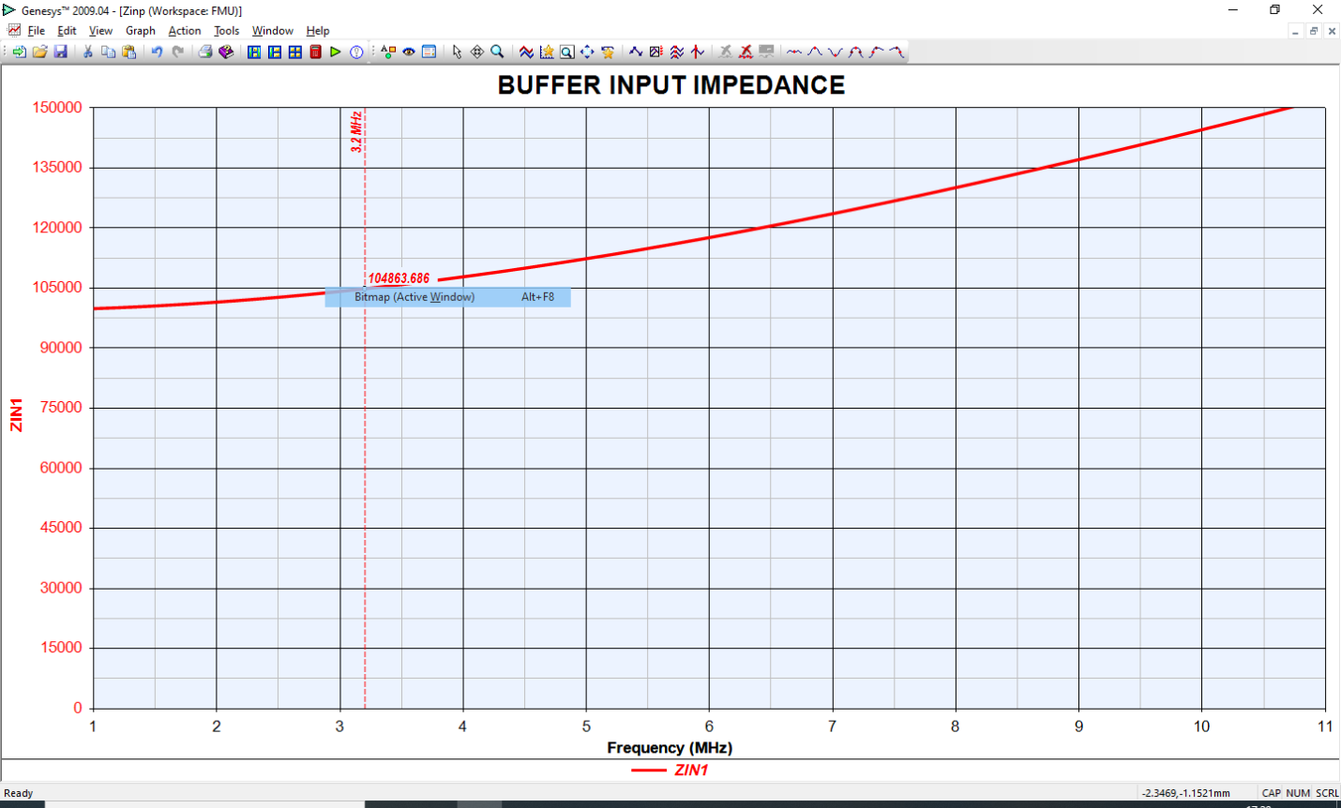

**Figure 12. the Buffer Input impedance**

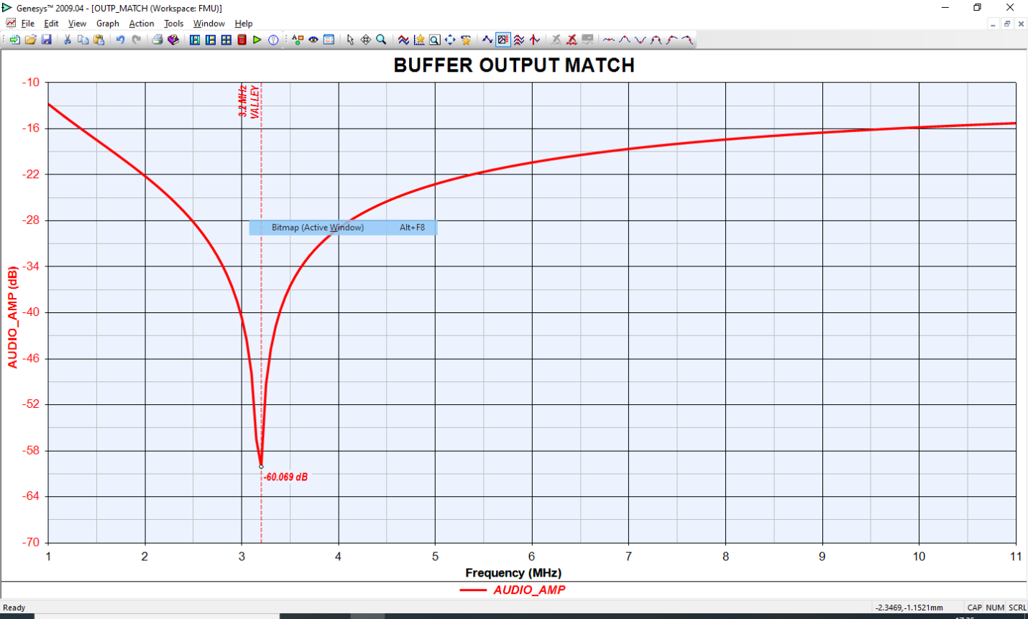

**Figure 13. Audio buffer amplifier output return loss optimized at 3.18 MHz**

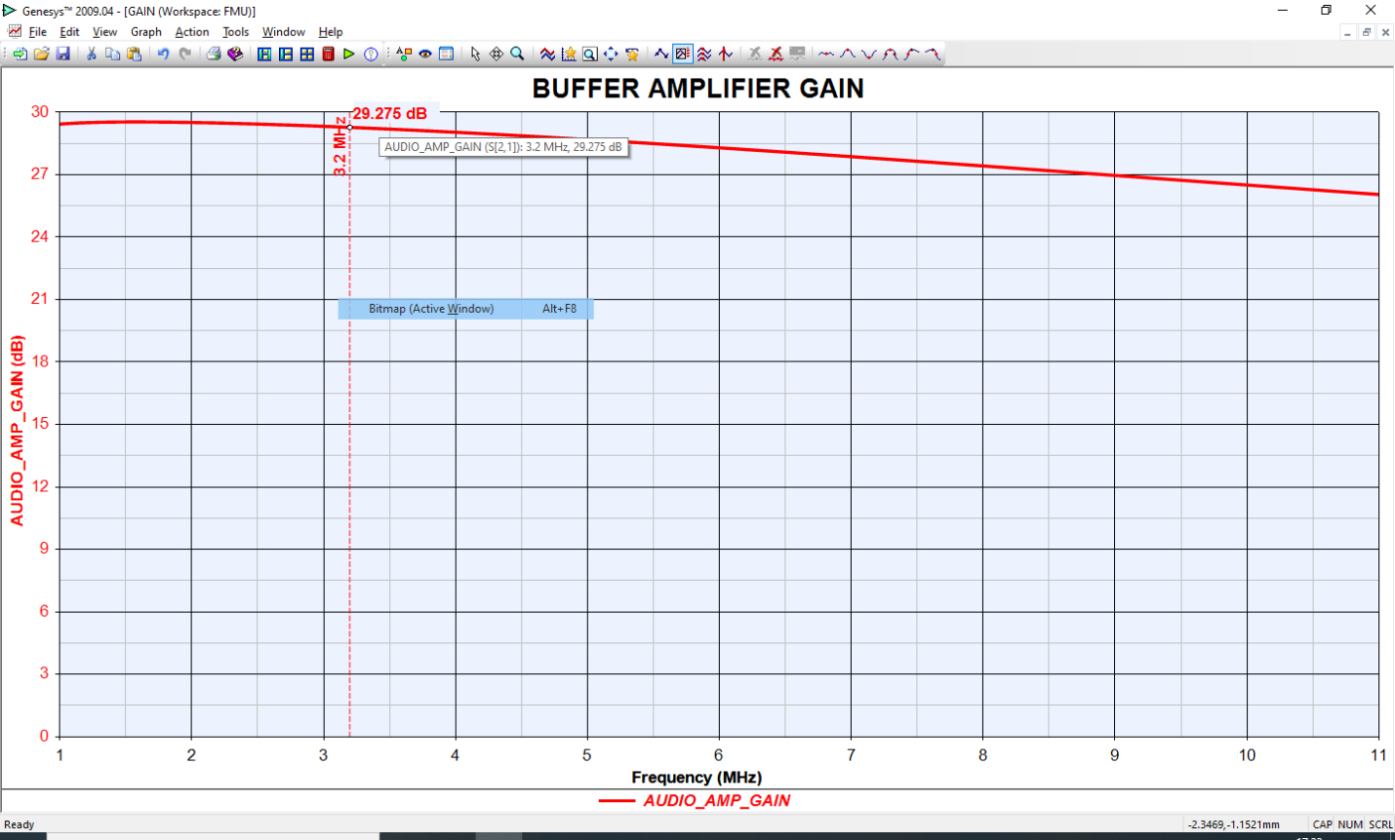

**Figure 14. The Audio Buffer Amplifier Gain**

It can be clearly seen from the above three figures that the audio signal buffer amplifier at 3.18 MHz has:

* A 104 kOhm input impedance
* A 60 dB output return loss with 50 Ohm load
* A 29.27 dB gain

**8.1.2. LO1 Buffer Amplifier**

Figure 15 shows the schematic diagram of the LO1 Buffer Amplifier.



**Figure 15. The LO1 signal buffer amplifier schematic**

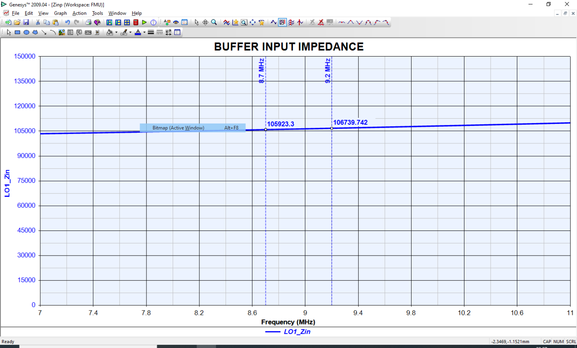

**Figure 16. The LO1 Buffer Input impedance**

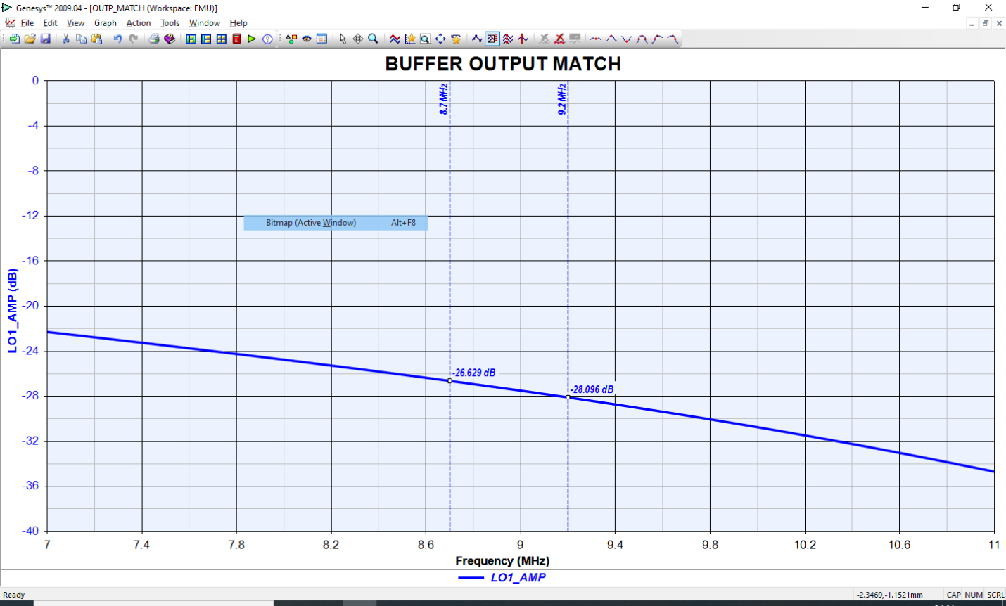

**Figure 17. LO1 buffer amplifier output return loss**

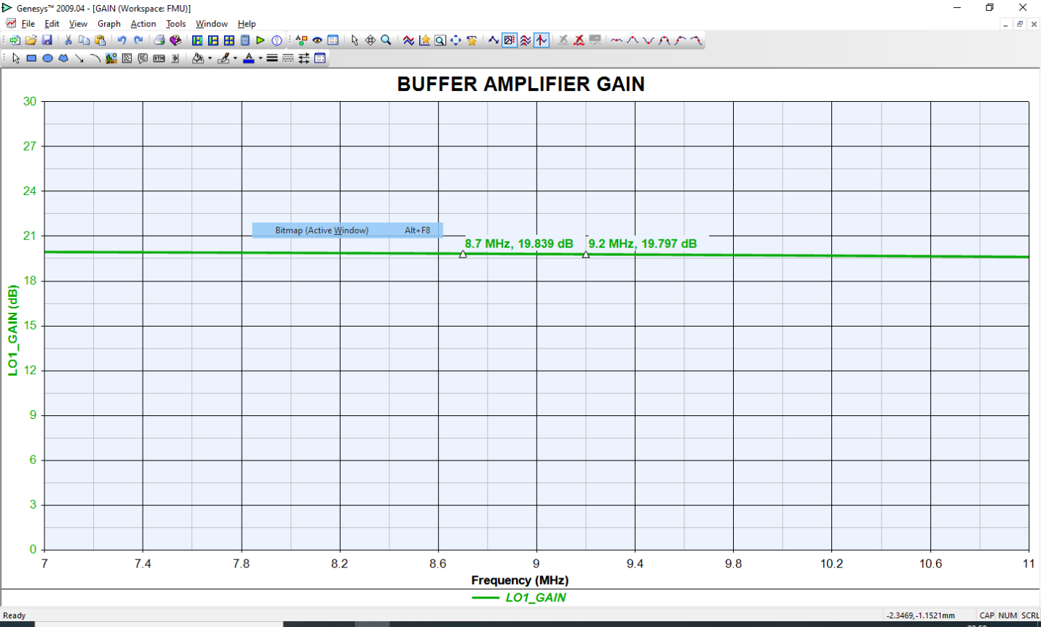

**Figure 18. The LO1 Buffer Amplifier Gain**

It can be clearly seen from the above three figures that the LO1 signal buffer amplifier in the frequency range 8.7 MHz to 9.2 MHz MHz has:

* An input impedance > 106 kOhm
* An output return loss with 50 Ohm load > 26.6 dB
* An RF gain > 8.7 dB. This gain has been adjusted and optimized to raise the 150 mV input LO1 signal to the required +7dBm level for driving the ADE-1+ mixer, shown in Figure 19. This mixer has been selected as the best mixer for the RFMU after a thorough research detailed comparisons. The LO signal at the mixer input is shown in Figure 20.



**Figure 19. the ADE-1+ Mixer**

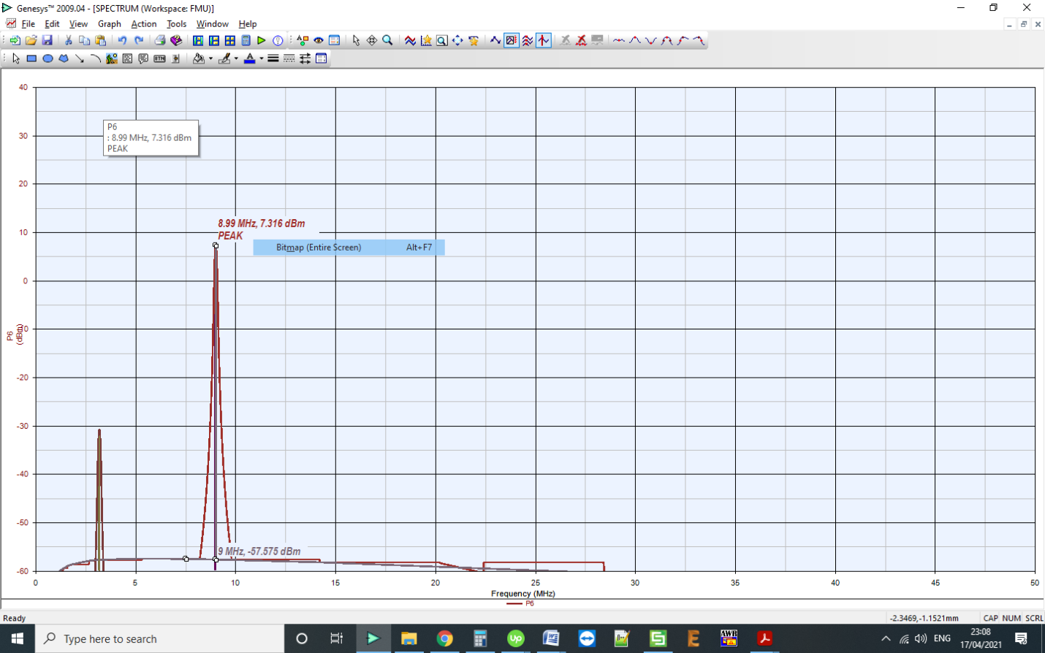

**Figure 20. The LO spectrum at the mixer input**

**8.1.3. LO2 Buffer Amplifier**

Figure 20 shows the schematic diagram of the LO2 Buffer Amplifier.



**Figure 20. The LO2 signal buffer amplifier schematic**

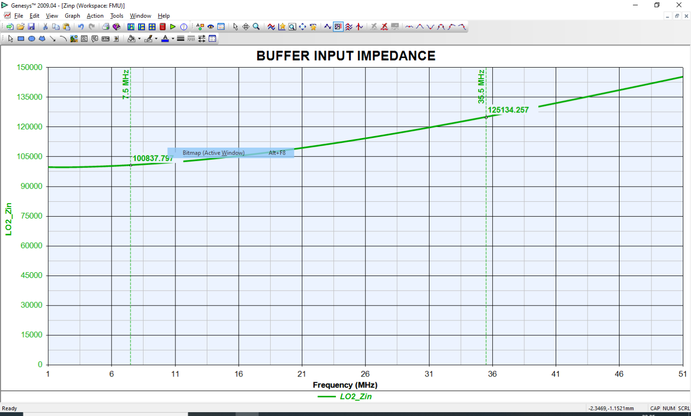

**Figure 21. The LO2 Buffer Input impedance**

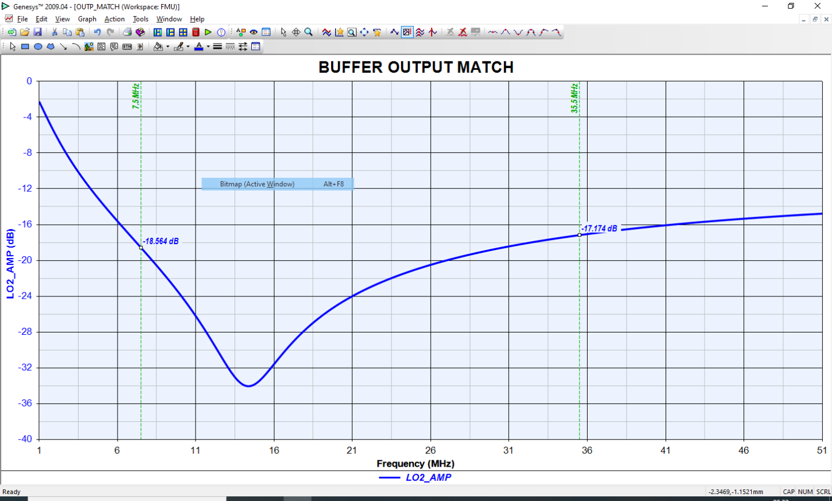

**Figure 22. LO2 buffer amplifier output return loss**

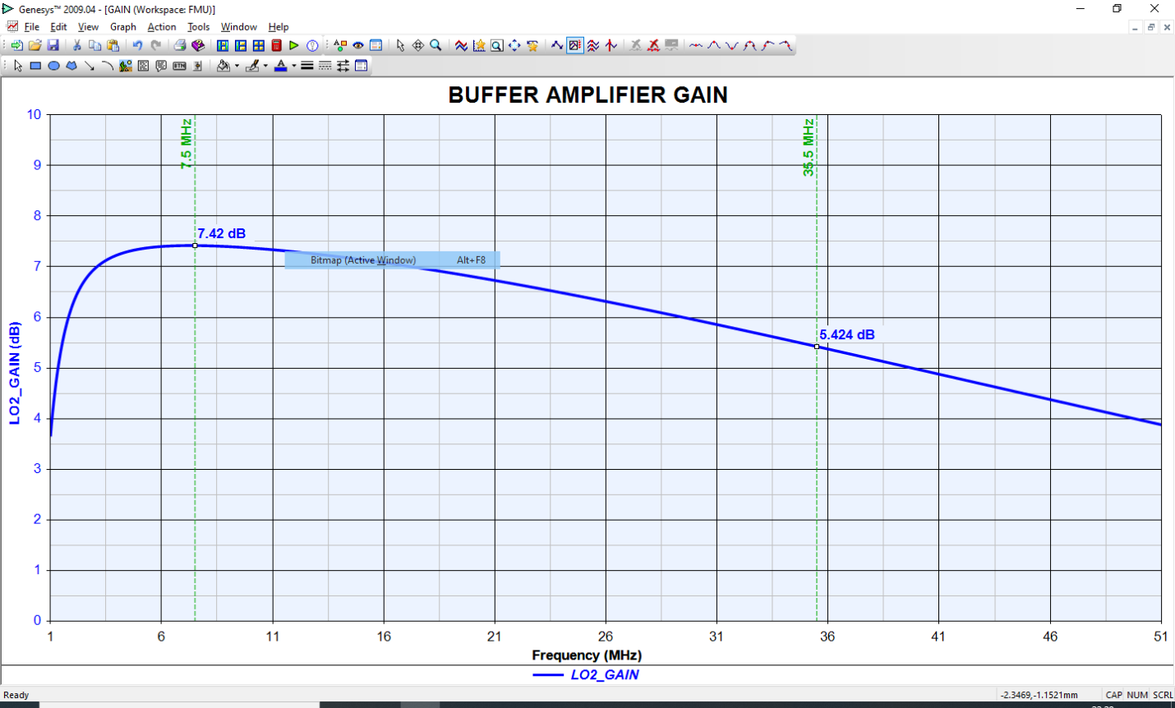

**Figure 23. The LO2 Buffer Amplifier Gain**

It can be clearly seen from Figures 21 TO 23 that the LO2 signal buffer amplifier in the frequency range 7.5 MHz to 35.5 MHz MHz has:

* An input impedance > 100 kOhm
* An output return loss with 50 Ohm load > 17.1 dB
* An RF gain between 5.42 dB and 7.42 dB along the frequency range 7.5 to 35.5 MHz. This gain has been adjusted and optimized to raise the 700 mV input LO2 signal to the required +7dBm level for driving the ADE-1+ mixer for the ten frequency bands of the LO2 starting from 7.5 MHz up to 35.5 MHz. The LO2 spectrum at the mixer input at the two extremes of its frequency values is shown in Figure 24.

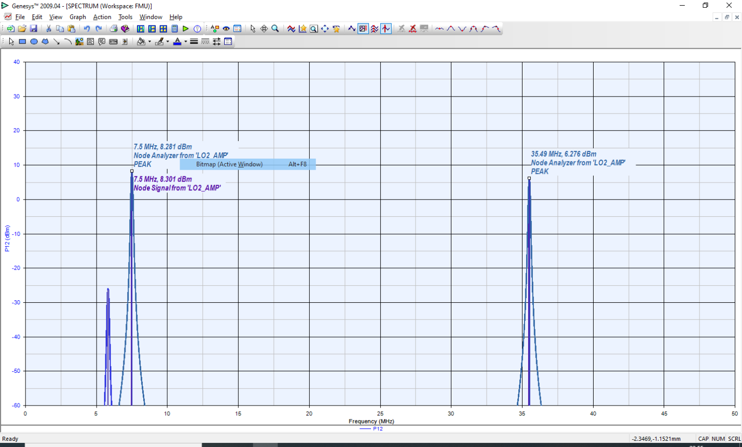

Figure 24. LO2 spectrum at the mixer input for different frequencies.

**8.2. First Mixer Output**

The first mixer mixes the 3.18 MHz received signal with the LO1 signal. The resulting spectrum is shown in Figure 25.

In Figure 25 we can see two mixer outputs with (fL - fA) and (fL + fA), where fL is the LO1 frequency, which is controlled by fine tuning between 8.7 and 9.2 MHz and fA is the receiver output signal frequency as taken from the NB Unit. The two output signals (5.81 MHz and 12.15 MHz) have nearly equal power levels (-6.88 and -7.44 dBm respectively), while a residual from the LO1 signal appears at the mixer output with reduced power (-22.7 dBm).

For proper operation, we need only the (fL - fA) component. Therefore, an IF (5.52 to 6.02 MHz) BPF is used after the first mixer to select the difference component.

In order to adjust the overall system gain, a 10 dB RF amplifier is inserted between the mixer output and the filter input as shown in the block diagram of Figure 10, repeated for convenience in the next figure.

A Mini Circuit’s MAR-3SM+ has been selected for this function.

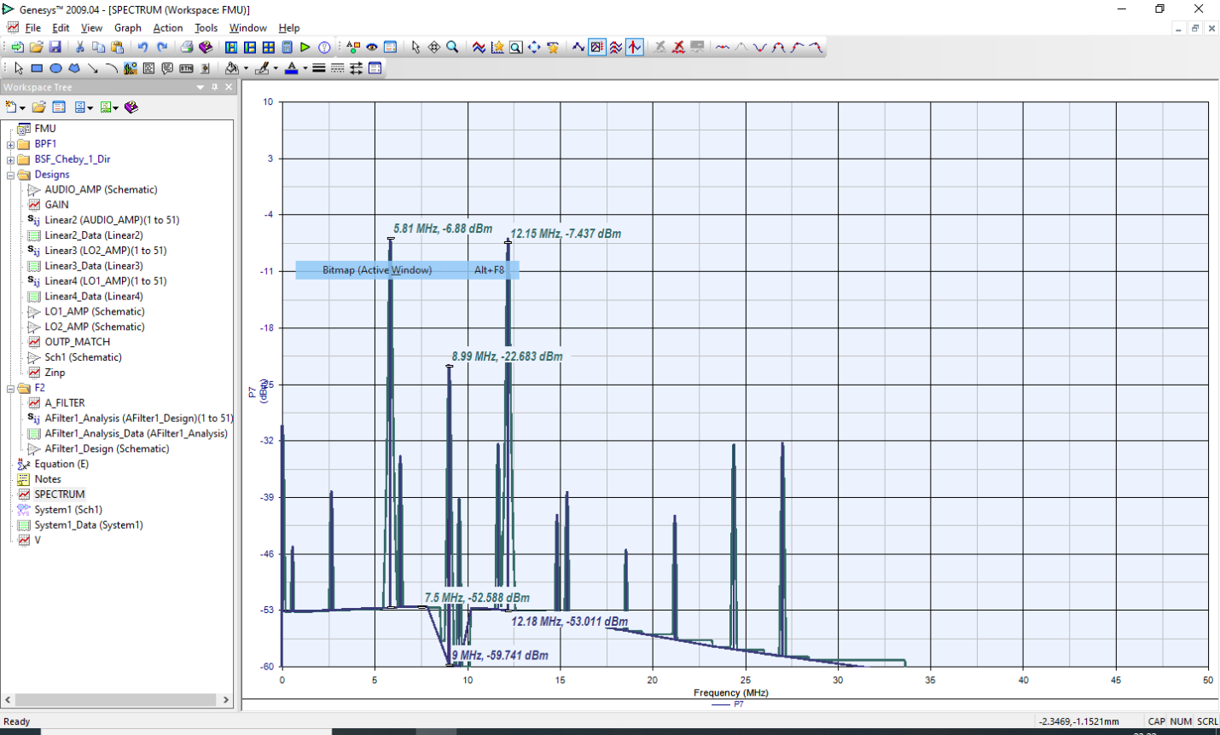

**Figure 25. First Mixer Output Spectrum**



**Figure 26. First part of the RFMU schematic**



**Figure 27. Thr MAR-3SM+ Amplifier.**

As the Vd is 5V and our supply is +5V, we don’t use a bias resistor.

Since the desired operation frequency is very small, we don’t need any bias choke. The amplifier is directly connected to the +5V power supply. Only the input and output blocking capacitors are used. A big value (1 F) has been selected for the DC blocking capacitances to minimize its effect on signal levels. The impedance of a 1 F at 5 MHz is of the order of 32 [m]. The layout of this part of the RFMU is shown in Figure 28.

In this figure we can see the two buffer amplifiers for the 3.18 audio signal and for the LO1. We can see the first ADE-1 mixer and the MAR3SM+ amplifier. The first mixer output goes to an edge smb connector, while the LO1 input comes through another edge smb connector and the 3.18 MHz signal via a two-pin connector.



**Figure 28. Layout of the first part of the RFMU.**

The MAR-3SM+ has a high gain at this low frequency band, of the order of 13 dB. This additional gain enhances the system performance at higher output frequencies where the overall gain decreases. The MAR-3SM+ gain vs. frequency characteristic is shown in Figure 29.



**Figure 29. The gain frequency characteristics of the MAR3SM+ amplifier**

The simulated spectrum at the amplifier output is shown in Figure 30.

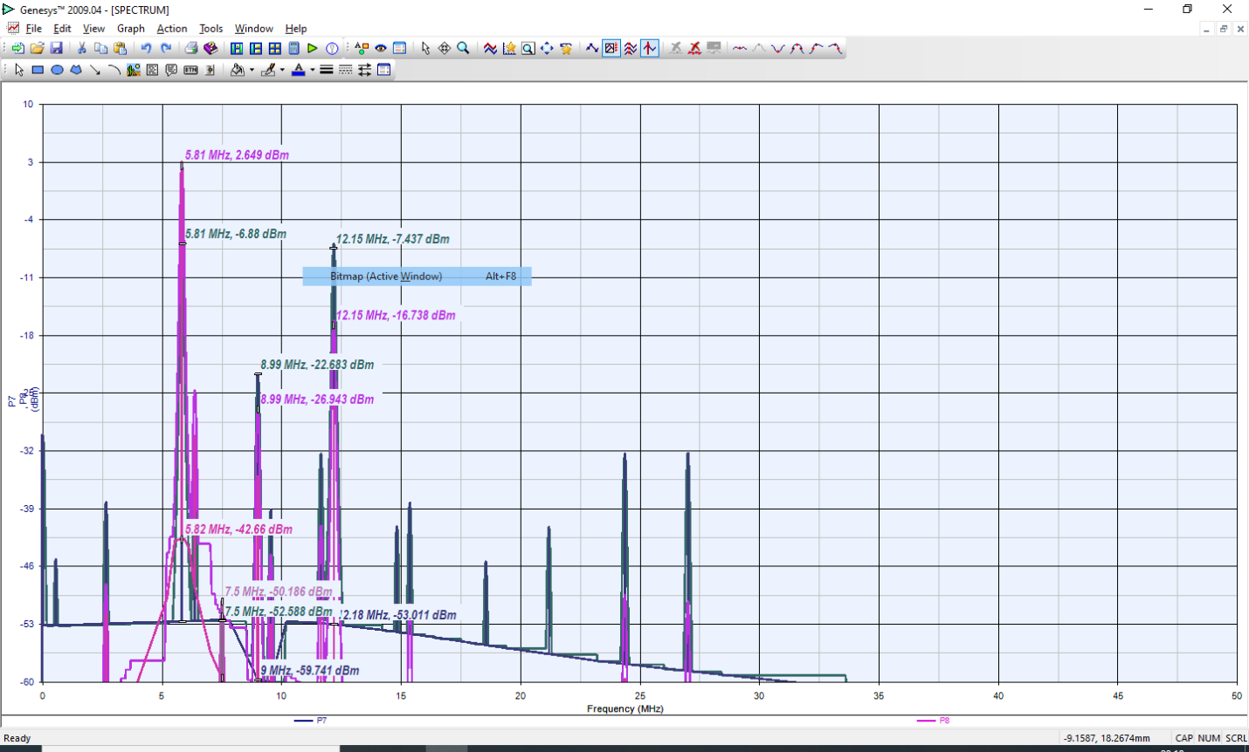

**Figure 30. the amplifier output spectrum**

**8.3. The IF Bandpass Filter**

This BPF is intended to select the lower side band of the mixer output and reject the upper side band. It should pass the (fL - fA) component and reject the (fL + fA) component of the mixer output. Since the LO frequency varies between 8.7 and 9.2 MHz and fA = 3.18 MHz; then the desired component lies in the range:

5.52 MHz < (fL - fA) < 6.02 MHz

The filter has been designed to satisfy these requirements.

Figure 32 a and b show the frequency response of the filter. While Figure 32a shows how the filter suppresses any higher frequency in the frequency range of the system, Figure 32b shows a detailed view of the filter passband.

The in-band insertion loss is about 4.2 dB and the return loss is better than 14 dB. This has been achieved by using high Q inductors of Coilcraft’s square air core inductors with Q values > 30 in the frequency band of interest.



**Figure 31. Square Air Core Inductors**

If other inductors were used, the filter selectivity, insertion loss and return loss would have been worse.

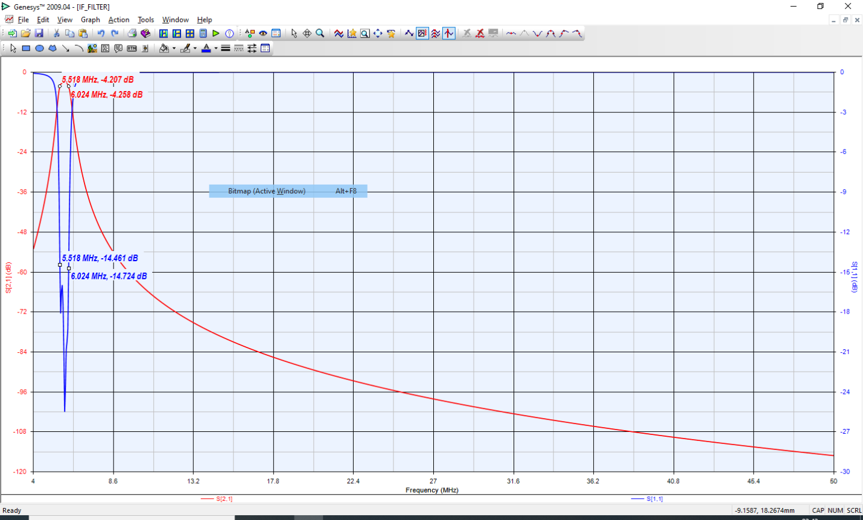

**Figure 32.a**

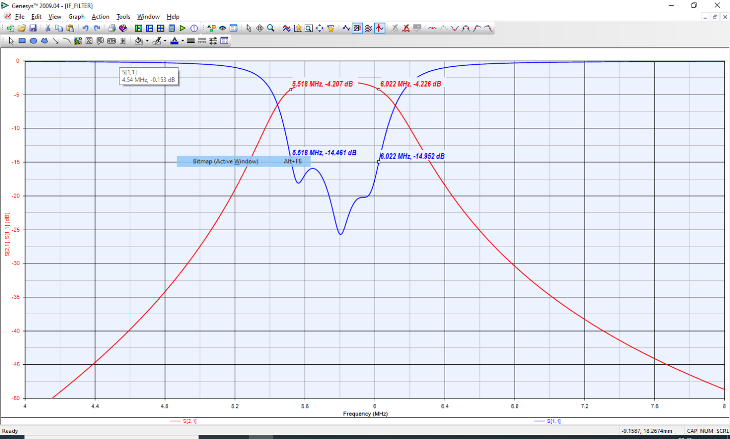

**Figure 32.b. The BPF Frequency Response**

Figure 33 shows the filter schematic diagram, while Figure 34 shows its layout drawing with the selected inductors.



**Figure 33. The BPF Schematic**



**Figure 34. The BPF Layout**